MPC5534 daughter Board

Hardware Requirement Specification
Rev-B

24-Apr-13

Ownership Disclaimer
This document contains proprietary and confidential material that is the sole property of Compressor Controls Corporation. The information contained herein is intended for internal use by Compressor Controls Corporation employees and is not intended for distribution outside of the company. As an unpublished work of trade secrets, the recipient shall keep this document confidential. Any re-use, copying, or distribution, either in whole or in part, of this material without the express written consent of Compressor Controls Corporation is strictly forbidden.
Copyright © 2011 by Compressor Controls Corporation. All rights reserved.

Revision History

Rev. | Date | Revised By | Description
0.1 | 24-Mar-11 | R.Vasavi | Initial Draft
0.2 | 31-Mar-11 | R.Vasavi | Updated with hardware requirements on CPLD for IOP-DM1 card and added requirements for FTC-DM1 card.
0.3 | 09-Aug-11 | R.Vasavi | Updated with review comments.  Updated with the design details as discussed with Tom
A | 06-Feb-13 | Vaibhav Doshi
B | 24-Apr-13 | Vaibhav Doshi

Approvals

Approved by: Date: _______________
Approved by: Date: _______________
Approved by: Date: _______________
Approved by: Date: _______________
Approved by: Date: _______________
Approved by: Date: _______________

TABLE OF CONTENTS

1 Introduction 6
1.1 Purpose 6
1.2 Audience 6
1.3 Scope 6
1.4 Acronyms 6
1.5 References 7
2 General Description 8
2.1 System Overview 8
2.2 Product Functions 9
2.3 Block Diagram 10
3 Electrical Requirements 12
3.1 Microcontroller 12
3.2 Power Supply Requirements 12
3.3 Clock 12
3.4 Flash Memory 12
3.5 SRAM Memory 13
3.6 MRAM memory 13
3.7 CPLD 13
3.8 EtherCAT Backplane Interface 13
3.9 Digital Inputs 13
3.10 Digital outputs 14
3.11 Frequency Inputs 14
3.12 Health Circuit of the IOP-DM1 card 15
3.13 Hot swap 15
3.14 Temperature Sensors 15
3.15 Supervisory Circuit 15
3.16 Power 15
3.17 Front Panel LEDs 16
3.18 Debug/ Diagnostic 17
3.19 ESD Protection 18
3.20 Components 18
3.21 Connectors 18
4 Mechanical Requirement 19
4.2 PCB Form Factor 19
4.3 Front Panel 19
5 Manufacturing Requirement 20
5.1 Fabrication 20
5.2 Assembly 20
6 Testing Requirement 21
7 Environmental Requirement 22

Introduction

Purpose
The purpose of this document is to capture the hardware requirements for MPC5534 daughter board. This board is the daughter board for the IOP-DM1 and IOP-AM1 boards of the New Generation Platform (NGP) control system.

Audience
This document is meant to be used by the project team members as the basis and controlling document for the design and development of MPC5534 daughter card.

Scope
The scope of this project is to design and develop the NGP boards where MPC5534 daughter board acts as the main microcontroller for processing the Digital inputs, Frequency inputs, generating the Digital outputs, Analog inputs and outputs. This document defines the product requirements to which hardware has to be designed and manufactured. This document also covers system level requirements applicable to MPC5534 daughter cards. This document doesn’t cover the firmware/ software related requirements.

Acronyms
Acronym | Definition
FTC | Field Termination Cards
ESC | Ethernet slave controller

References
[1] Detailed Functional Specification for NGP Hardware, Part 1, Rev-3
[2] System Study for New Generation Platform Electronics and Bring-up, Rev-1
[3]Reference Manual of MPC5534.
[4] Vaguard_TheoryOfOperation_Healthy Logic.pdf from CCC

General Description

System Overview
New Generation Platform (NGP) is a fully redundant, duplex, highly available, fault tolerant control system intended to handle a number of digital, analog and frequency IOs in industrial applications. Below is the system block diagram of NGP.

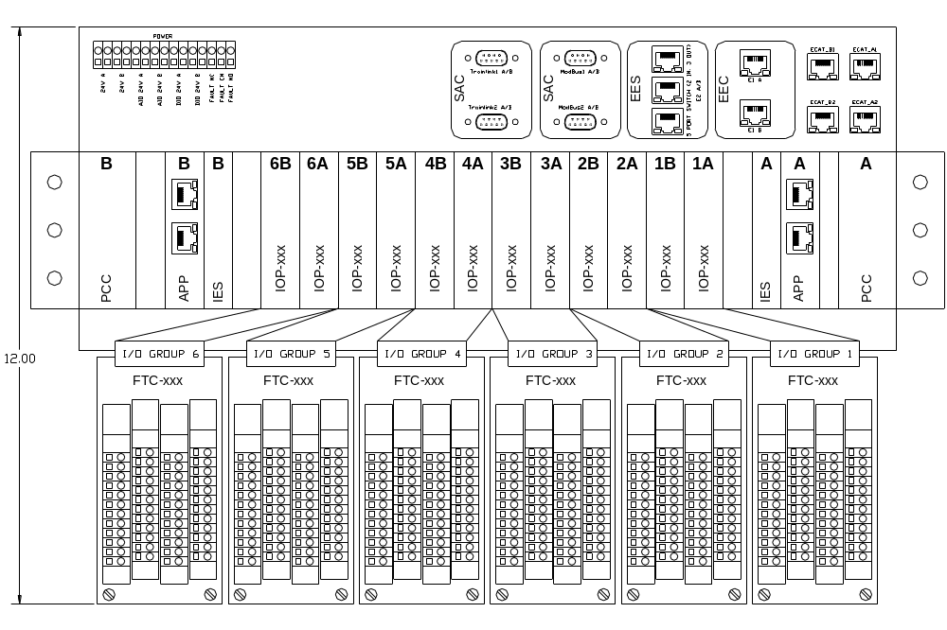
Here is the list of different electrical components in the system and their brief description.

APP
This is the main processing unit in the system. This runs the main application and does monitoring and control of the overall system. There will be a maximum of 2 such cards in an NGP system.

IOP (Digital and Analog)
These are the processors cards which handle digital, analog and frequency IOs. There will be a maximum of 12 such cards in an NGP system.

IES
This is the EtherCAT switch card used to interface between different APP and IOP modules. There will be a maximum of 2 such cards in an NGP system

PCC
This is power conversion card. The input power (redundant 24VDC) to the system first comes to this card. This card does the oring, filtering, protection and other voltage conversion. There will be a maximum of 2 such cards in an NGP system

FTC (Digital and Analog)
These ate the field terminal cards where all the field loads are connected to. These are electrically interfaced to IOP cards. The number of FTC in an NGP system is same as the number of IOP card

CAC
These are the set of communication (Ethernet, RS-485) cards used for interface to the external devices

Backplane
All the above mentioned boards plug in backplane and communicate to each other over it.

Product Functions
MPC5534 daughter board shall be built on Freescale MPC5534 microcontroller. It shall provide interfaces to various memories and implements Ether CAT slave controllers to communicate to IES cards in the system. It communicates with the IOP base boards and processes the Digital IOs, Analog IOs and frequency inputs.

2.3 Acceptance Criteria
Mindteck shall design, develop and deliver the hardware meeting the functionalities as detailed in section 3.0

Assumptions
MPC5534 daughter board shall provide only the electrical connections for the IOP boards.

2.5 Dependencies
Finalization of all components and connectors shall be approved by CCC.
MPC5534 daughter board dimensions shall be approved by CCC.
CCC shall ensure availability of about 10% time from an CCC’s representative for addressing queries, reviews and acceptance
Timely inputs, reviews and approvals
Assistance in the finalization of all the requirements specification documents
Validation testing and approval of prototypes

3. Block Diagram
The block diagram gives the high level architecture of the IOP boards having MPC5534 as the daughter board.

IOP Base board

MPC5534 daughter board

Back Plane

The detail block diagram for the MPC5534 daughter board is shown below,

MPC5534 board

CS3/
LED GPIOs

eMIOS

Freq Inouts

Digital Inouts

eTPU

Digital Outputs

I2C BUS1

I2C BUS2

EEPROM

Microcontroller
MPC5534
Spansion FLASH
Cypress SRAM
Nexus Debug Connector
RS485 Driver
ADM3490
EtherCAT slave controller
ET1100
MPC5534-IOP Inter-board connector
Temperature Sensor & Voltage monitor
EEPROM
DATA
(15:0)
16
3
16
UART
ADDR (18:0)
CS0/
To
IES card1
CS1/
SPI B port
Everspin
MRAM

Health CPLD
EPM3064
CS2/
GPIOs
To
IES card2
ADC
Connector
EtherCAT slave controller
ET1100

EEPROM
SPI D port
SPI EEPROM
SPI C port
JTAG Conn
I2C

I2C

Electrical Requirements

Microcontroller
Freescale MPC5534 microcontroller shall be implemented as main processing unit.
Design shall be compatible with frequencies of 40MHz, 66MHz and 80MHz of the processor
Non RoHS version of MPC5534 shall be used.
    - RESET configurations
The PLLCFG [1:0], BOOTCFG [1:0], WKPCFG and RSTCFG pins shall have jumpers for pull-up/pull-down options which will enable to have the following configurations
- Selection for boot between internal flash or external flash device.
- Use of internal clock crystal frequency or external oscillator.

Power Supply Requirements
We shall be using LTC3633 which is a switch Mode Power Supply required for the board’s 3.3V and 1.5V requirements. A separate LDO for 5V and a reference voltage generator shall also be used.

Clock
Option shall be provided to use either internal clock from crystal or from external source. The clock option is selected by PLLCFG [1:0] pins during the power on reset configuration. Crystal of 8MHz will be used for internal clock generation. Option to use external clock oscillator shall also be provided.

Flash Memory
    - 512K x 16 bit NOR Flash shall be implemented.
The Flash device will be interfaced to the MPC5534 through the External bus interface using chip select 0. The flash memory from spansion part no. S29AL008J70BFI02 shall be used.

SRAM Memory
    - 512K x 16 bit SRAM shall be implemented
The SRAM device will be interfaced to the MPC5534 using the Chip select 1. Asynchronous SRAM from cypress part no. CY7C1051DV33-10BAXI shall be used.

MRAM memory
    - 4M bit MRAM shall be implemented
The MRAM device will be interfaced to the MPC5534 using the chip select 2.
The Ever spin device part no. MR2A16AMA35 shall be used with the higher address bit grounded. .The footprint shall be compatible with 16Mb MRAM as well as nVSRAM for future purpose.

CPLD
The Health logic circuit related to MPC5534 and the duplex functionality of the IOP card shall be implemented in CPLD.
Altera MAX3000 series device part no. EPM3064ATI100-10N having 64 macro cells shall be used.

EtherCAT Backplane Interface
    - Two EtherCAT slave controllers shall be implemented on the SPI ports B & D.
    - These two EtherCAT ports one from each ESC shall be routed to the backplane connector over the IOP boards.
The EtherCAT slave controller ET1100 device from Beckhoff shall be used. Each EtherCAT loop can have only one master hence two ESC are required to realize the redundancy. The ESCs are interfaced to MPC5534 through the SPI B and SPI C ports. The same data will be flowing on both the SPI C and SPI D ports. The two ports from two ESC devices will be routed to the two IES cards over the backplane.
EEPROMs are required to store the configuration of ET1100. These EEPROMs shall be read by the MPC5534 on initial bootup.

eTPU interface – Digital/Frequency Inputs
Enable
The digital/frequency inputs from the IOP-DM1 board shall be taken to the eTPU interface. The 16 channels of eTPU are assigned to the digital inputs out of which 10 inputs will be coming from the IOP-DM1 board. The rest of them are for future enhancements. The 3 channels of eTPU are assigned to the frequency inputs coming from the IOP-DM1 board.

eMIOS - Digital outputs
The eMIOS shall drive out the 16 digital outputs to the IOP-DM1 board out of which only 6 have been used and rest of them will be used for future enhancements.

Temperature Sensors
Analog temperature sensor shall be used to monitor the on-board temperatures. TMP36 device from analog devices shall be used. The output voltage from the sensor is given to the ADC input of the MPC5534 microcontroller.

Voltage monitor
The different voltages used on board and from the IOP boards shall be given as the input to ADC channels of the MPC5534 microcontroller device through the unit gain amplifier ADA4096.

Supervisory Circuit
Reset controller with built-in watch dog timer device shall be provided on board. The reset controller shall also support
- On board switch de-bounce.
- Reset out from Hot Swap controller.

LEDs
Name | Function | Color
POWER | Power Supply status ok | Blue-CCC
ACTIVE | Card is controlling output channels | Green
READY | Card is healthy and has no detectable faults | Green
ALARM | Card has a detectable non-critical issue | Yellow
FAULT | Card has a critical error | Red
 | CPU is active/heartbeat | Green
  CPU
LEARN | Card in initializing/booting/learning from peer | Green
ESC1 Link/activity | Indicates the Link/activity status for ESC1 | Green
ESC2 Link/activity | Indicates the Link/activity status for ESC2 | Green
ESC1 Run | Indicates the RUN status for ESC1 | Green
ESC2 Run | Indicates the RUN status for ESC2 | Green

All these LEDs shall be implemented in the IOP boards.

Debug/ Diagnostic
    - JTAG/Nexus Port
JTAG port shall be implemented to test chip functionality and connectivity and also device programming. The JTAGC uses JCOMP and a power-on reset indication as its primary reset signals.
Nexus Development interface uses Auxiliary port and JTAG port for debugging the microcontroller code executions. Nexus allows for program, data and ownership trace of the microcontroller execution without access to the external data and address buses.
14 pin JTAG/Nexus board edge connector shall be provided. on MPC5534 daughter board.
    - Diagnostic RS-485 Port
A diagnostic RS-485 port shall be implemented on board using a 6-pin header depending on the feasibility. The position of the header should be such that it is easily accessible when the card is installed in the system.
    - Manual Reset Switch
A manual reset switch shall be implemented for development/ debug purpose. The position of the reset switch should be such that it is easily accessible when the card is installed in the system. Hence the switch shall be placed on the IOP boards.
    - Test Points
Clip-on test points shall be implemented for key signals including all power and ground rails. The test points should be reasonably spaced to prevent test connection shorting while testing.
    - Logic Analyzer Connection
Logic analyzer connection port shall be implemented for External interface bus signals. Mictor connector shall be provided on board for the debugging purpose.

Components
    - All the components shall meet industrial temperature ratings
    - Any BGA parts used shall be Non-RoHS
    - All other parts can be either RoHS or Non-RoHS

Connectors
    - Two numbers of Samtec part no. QSE-040-01-L-D-A connector shall be used for the IOP board connections

Mechanical Requirement
    - Schematic design file name should be 18-600500-001.sch
    - PCB design file name should be 17-600500-001.pcb

PCB Form Factor

The size of the MPC5534 daughter board shall be 121mm x 122.98mm

5. Not in scope

- User manual, tutorial or any other user documentation
- Certification, environmental, ATEX testing, EMI/EMC testing
- Mechanical / enclosure design or prototyping and assembly

5.1 Deliverables

Mindteck shall deliver the following hardware deliverables as per the project plan for CCC review and acceptance…

- Hardware Requirements Specifications document
- Hardware Design Document
- Backplane board schematics design files
- Board Layout files & Gerber files
- Backplane board Bill of Materials
- Tested prototypes
- Test reports

